**-------- CALCULATION OF GPA -------------**

int n, c_h, c_h_t = 0; // c_h = credit hour --- c_h_t = credit hour totals ----- m = marks

double gp, gpp, gpp_t = 0, gpa = 0, m;

Console.Write("enter no of courses: ");

n = int.Parse(Console.ReadLine());

string[,] array = new string[n, 6];

for (int i = 0; i < n; i++)

{

array[i, 5] = "0";

Console.Write("enter course code: ");

array[i, 0] = Console.ReadLine();

Console.Write("enter course name: ");

array[i, 1] = Console.ReadLine();

Console.Write("enter credit hour of this course: ");

array[i, 2] = Console.ReadLine();

c_h = int.Parse(array[i, 2]);

c_h_t = c_h_t + c_h;

Console.Write("enter marks of this course: ");

array[i, 3] = Console.ReadLine();

m = double.Parse(array[i, 3]);

if (m >= 87 && m <= 100)

{

array[i, 4] = "4";

}

else if (m >= 80 && m < 87)

{

array[i, 4] = "3.5";

}

else if (m >= 72 && m < 80)

{

array[i, 4] = "3.0";

}

else if (m >= 66 && m < 72)

{

array[i, 4] = "2.5";

}

else if (m >= 60 && m < 66)

{

array[i, 4] = "2.0";

}

else if (m >= 50 && m < 60)

{

array[i, 4] = "1.5";

}

else

{

array[i, 4] = "0";

}

gp = double.Parse(array[i, 4]);

gpp = double.Parse(array[i, 5]);

gpp = gp * c_h;

gpp_t = gpp_t + gpp;

array[i, 5] = Convert.ToString(gpp);

}

Console.Clear();

Console.WriteLine("NAME= AHSAN SAJJAD");

Console.WriteLine("FATHER NAME= ABDUL HAQ");

Console.WriteLine("PROGRAM= SOFTWARE ENGINEERING");

Console.WriteLine("SECTION= BSE 1B");

Console.WriteLine("GUESS RESULT OF 1st SEMESTER");

Console.WriteLine("TODAY DATE: 25/12/21 -- QUAID DAY\n");

Console.WriteLine("c_codes\t\tc_name\t\t\tcredit hour\tmarks\t\tGP\t\tGPP\n");

for (int x = 0; x < n; x++)

{

for (int y = 0; y < 6; y++)

{

Console.Write(array[x, y] + "\t\t ");

}

Console.WriteLine();

}

gpa = gpp_t / c_h_t;

Console.WriteLine(" \n\n\t GPA = " + gpa);

Console.WriteLine("\n\t\t I N S H A A L L A H");

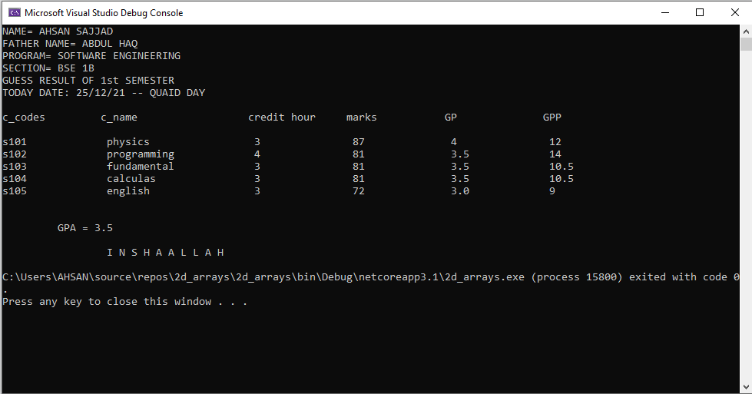

************************ MIN MAX IN ARRAY ********************

**SOLUTION:**

int max = 0, min=0;

Console.Write("enter length of an array: ");

int n = int.Parse(Console.ReadLine());

int[] arr = new int[n];

Console.WriteLine("enter series");

for (int i = 0; i < n; i++)

{

arr[i] = int.Parse(Console.ReadLine());

}

for (int i = 0; i < n; i++)

{

if (i==0)

{

min=arr[i];

max = arr[i];

}

if (arr[i]>max)

{

max = arr[i];

}

if (min>arr[i])

{

min = arr[i];

}

}

Console.WriteLine("maximum num in array: "+ max);

Console.WriteLine("minimum num n array: {0}", min);

**OUTPUT:**

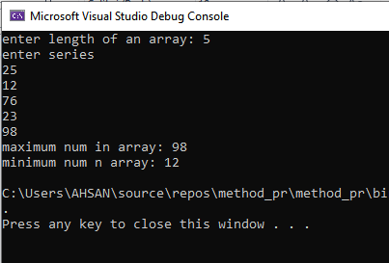

************ min max using method ***************

**SOLUTION:**

{

Console.Write("enter the size of array: ");

int n = int.Parse(Console.ReadLine());

int[] arr = new int[n];

Console.WriteLine("enter the values of array: ");

for (int i = 0; i < n; i++)

{

arr[i] = int.Parse(Console.ReadLine());

}

Console.WriteLine("Reverse of above series: ");

for (int i = n-1; i >=0 ; i--)

{

Console.WriteLine(arr[i]);

}

}

static void Main(string[] args)

{

array();

}

**OUTPUT:**